UPPWISE INDIA

www.uppwise.com

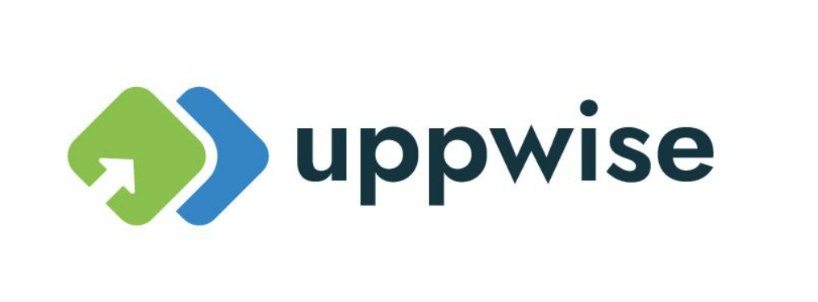

**Quaterly Development Planning**

**Q4-2023**

**Feature: Kanban Over Collaboration**

**Feature Title:**

Kanban Over Collaboration

**Priority:**

Medium

**Submitted By:**

SPM

**Target Users:**

Standard SPM User

**Feature Description:**

Introducing a new feature that enhances collaboration management by integrating Kanban views, providing users with an advanced method to organize and oversee their collaboration forms.

**Acceptance Criteria:**

The feature will be considered successfully implemented when the following criteria are met: Seamless toggling between Kanban and Grid View options is available to users.

**Feature Roadmap Ahead:**

**Sub-Feature 1: Allow Users to Switch Between Kanban and Grid View**

* Users should have the ability to easily switch between Kanban and Grid views, providing flexibility in how collaboration forms are visualized.

**Sub-Feature 2: Support Multiple-Workflow View in Kanban**

* In the Kanban view, users should be able to navigate through workflow steps, with an additional option to choose between different workflows if the collaboration object supports multiple workflows.

**Sub-Feature 3: Allow Users to Add Dynamic Fields on the Kanban View**

* Recognizing the dynamic nature of collaboration form fields, this sub-feature empowers users to include customized and dynamic fields directly within the Kanban view.

Example: In the below Dropdown we can show this field as a lane and the user can manage this via Kanban with better visualization.

**Sub-Feature 4: Allow Users the Option to Personalize Card Details**

* Users will be given the capability to personalize card details, accommodating the dynamic nature of collaboration form fields and ensuring a tailored experience.

**Sub-Feature 5: Manage and Save Object Fields in Kanban View via Drag and Drop**

* This sub-feature empowers users with the capability to modify, update, and save values directly within the Kanban interface. This functionality ensures a seamless and efficient user experience, allowing for real-time collaboration form management.

**Additional Notes:**

* **Conditional Workflow Exclusion:**

As of now, the implementation does not cater to collaboration objects operating under conditional workflows. Future considerations may arise for extending this feature to encompass such scenarios.